
LILLINGTON
PRESBYTERIAN
CHURCH
December 3, 2023
First Sunday of Advent
† You are invited to stand when you see this symbol.

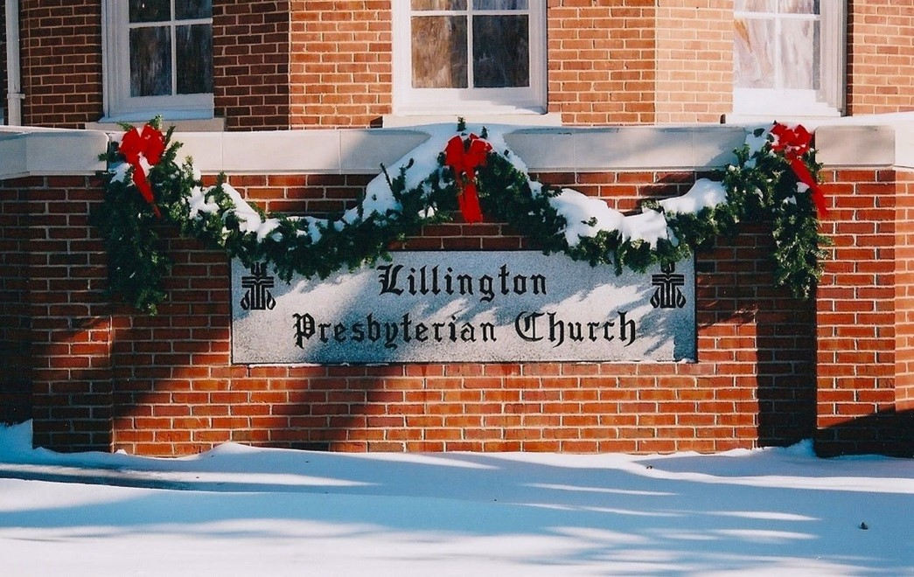

PRELUDE Prepare the Way, O Zion

WELCOME AND OUR LIFE TOGETEHR

INTROIT The Coming of the Lord
(Children and Youth are invited to line up outside at 10:55 am and bring in ornaments)

LIGHTING OF THE ADVENT WREATH
The world says, “All is lost.”
God says, “All is loved.”
The darkness says, “The light is dying.”
The light says, “The fire is catching.”
Fear says, “Cover your eyes and your ears.”
Hope says, “Wait, watch, and listen.”

As we light our first Advent candle,
we pray for holy hope of God.
Come now, O Child of Mary.
Come now, O Prince of Hope

† HYMN#85 Light One Candle to Watch for Messiah (v1)
Light one candle to watch for Messiah:
Let the light banish darkness.
He shall bring salvation to Israel,
God fulfills the promise.

† CALL TO CONFESSION

† PRAYER OF CONFESSION
(silent prayer)
Lord, have mercy on us.
We are not ready for your coming.
We live in sin, as though there were no grace.
Forgive us, Lord.
Show us your mercy and steadfast love.
Lead us in your truth, and teach us your paths,
for you are the God of our salvation. Amen.

† ASSURANCE OF PARDON
The Lord is our righteousness.
In Christ, we are forgiven.
Thanks be to God! Amen.

† RESPONSE OF PRAISE O Little Town of Bethlehem v.4

O holy child of Bethlehem, descend to us, we pray;
cast out our sin and enter in; be born in us today.
We hear the Christmas angels the great glad tidings tell;
O come to us; abide with us, our Lord Emmanuel!

FAITH SHARING WITH CHILDREN

PRAYER OF ILLUMINATION

1st Reading Genesis 1:1-5 _{page 1 OT}
Homily

Congregational Response While We Are Waiting, Come
(please remain seated)
While we are waiting come; while we are waiting come;
Jesus, our Lord, Emmanuel, while we are waiting come.
With power and glory, come; with power and glory come.
Jesus our Lord, Emmanuel, while we are waiting come.
Come, Savior, quickly come; come savior, quickly come.
Jesus our Lord, Emmanuel, while we are waiting come.
2nd Reading Isaiah 40:1-8 _{page 667 OT}
Homily

Music Response “My Soul in Stillness Waits”

Congregation is invited to sing the refrain after each solo.
Refrain: For you, O Lord, my soul in stillness waits; truly my hope is in you.

3rd Reading 2 Peter 1:16-21 _{page 236 NT}
Homily

Congregational Music Response #88 O Come, O Come, Emmanuel (v 1,2)
(please remain seated)

4TH Reading John 1:1-5 _{page 91 NT}
Homily

Prayer

INVITATION TO OFFERING AND PRAYER OF DEDICATION

OFFERING MUSIC O Come, O Come, Emmanuel

† DOXOLOGY In the Bleak Midwinter v. 4

What can I give him, poor as I am?
If I were a shepherd, I would bring a lamb;
if I were a wise man, I would do my part;
yet what I can I give him: give my heart.

PRAYERS FOR THE PEOPLE AND THE LORD’S PRAYER

Let us pray to the Lord, saying:
“in your mercy, Lord, save us.”

...Our Father who art in heaven, hallowed be thy name. Thy kingdom come, thy will be done, on earth as it is in heaven. Give us this day our daily bread; and forgive us our debts, as we forgive our debtors; and lead us not into temptation, but deliver us from evil. For thine is the kingdom and the power and the glory, forever. Amen.

† HYMN#105 People Look East

CHARGE AND BENEDICTION

POSTLUDE Awake! Awake! And Greet the New Morn

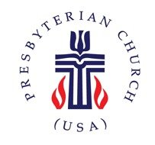
Church Information

Mailing Address: | PO Box 245 Lillington, NC 27546
Phone: | 910-893-3545
Website: | www.lillingtonpres.org
Office Hours: | M-F 9am-1pm

Church Staff
Minister: Rev. Barrett Payne | pastor@lillingtonpres.org  828-242-1718
Music Director: Wanda Brown | music@lillingtonpres.org  910-890-0900
Children’s Ministry Director:  Amanda Inguanza | christianed@lillingtonpres.org
Administrative Asst.:  Paula Stephenson | office@lillingtonpres.org  910-893-3545
Sextons: Rose and Elmon Pipkin, Jr

Session

Moderator: Rev. Barrett Payne
Clerk: Jim Cruickshank

Class of 2023 | Class of 2024 | Class of 2025
Liz hill | Derrick graham | James cox
Katie knodel | Susan ashworth | Bonnie cruickshank
Josh smith | Ray collins | Lynn nash
John wilbourne | Brenda langdon | Steve plummer

Search Lillington Presbyterian Church on your favorite podcast provider
for more sermons and series.

