
LILLINGTON
PRESBYTERIAN
CHURCH
October 27, 2024
Twenty-third Sunday after Pentecost
† You are invited to stand when you see this symbol.

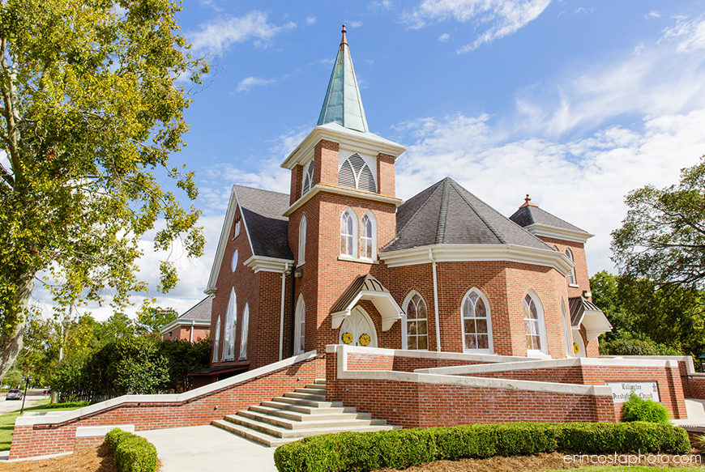

PRELUDE The House of the Lord

WELCOME AND OUR LIFE TOGETHER

† CALL TO WORSHIP
Leader: Jesus began his ministry to the world,
led by the Spirit into the wilderness.
People: As we worship and live our lives, let us be led by the Spirit,
even into the uncomfortable places.
In those forty days, and in that place,
Jesus was faced with hunger, doubt and temptation.
As we seek to follow Jesus, we would be led,
even into the uncomfortable choices.
Jesus left the wilderness, faithful and obedient to God,
rejoicing in the One in whom he trusted.
As we continue on our path to faithfulness,
we will be led by our Christ, rejoicing in the Lord our God.
† HYMN #610 O for a Thousand Tongues to Sing _{AZMON}

† CALL TO CONFESSION

† PRAYER OF CONFESSION
(silent prayer)
Gracious and merciful God, we confess to you our reluctance to enter the wilderness places where we are confronted with our true selves. The places where we are tempted to put worldly values before our desire for you, and when our hunger for power and wealth is greater than our hunger for seeking and doing your will: Forgive us, O God, and increase our trust in you.

When we are tempted to use the gifts you give us to benefit ourselves at the expense of serving others: Forgive us, O God, and increase our trust in you.

When we are tempted to use bribery to influence and control people: Forgive us, O God, and increase our trust in you.

When we are tempted to manipulate you, O God, to satisfy our own needs: Forgive us, O God, and increase our trust in you. Amen

† ASSURANCE OF PARDON
Believe the good news of the gospel:
In Jesus Christ, we are forgiven.
Thanks be to God!

† PASSING OF THE PEACE
May the peace of Christ be with you.
And also with you.

† RESPONSE OF PRAISE Glory to God
Glory to God, whose goodness shines on me,
and to the Son, whose grace has pardoned me,
and to the Spirit, whose love has set me free.
As it was in the beginning, is now and ever shall be. A-men.
World without end, without end. A-men. (3x)
As it was in the beginning, is now and ever shall be. A-men.

FAITH SHARING WITH CHILDREN

PRAYER OF ILLUMINATION

ANTHEM Rise Up and Sing Chancel Choir

GOSPEL LESSON Matthew 4:1-11 _{page 3 NT}
SERMON Muriel Lasater-Sizemore

† HYMN #175 Seek Ye First _{LAFFERTY}

† AFFIRMATION OF FAITH Apostles Creed
I believe in God, the Father Almighty,
maker of heaven and earth,
and in Jesus Christ, His only Son, our Lord:
Who was conceived by the Holy Ghost,
born of the virgin Mary, suffered under Pontius Pilate,
was crucified, dead, and buried; He descended into hell.
The third day He arose again from the dead;
He ascended into heaven,
and sitteth on the right hand of God the Father Almighty;
from thence he shall come to judge the quick and the dead.
I believe in the Holy Ghost; the holy catholic church;
the communion of saints; the forgiveness of sins;
the resurrection of the body; and the life everlasting. Amen.

INVITATION TO OFFERING AND PRAYER OF DEDICATION

OFFERING MUSIC When We Are Tested

† DOXOLOGY _{DOXOLOGY}
Praise God, from whom all blessings flow;
Praise Him, all creatures here below;
Praise Him above, ye heavenly host;
Praise Father, Son, and Holy Ghost. Amen.

PRAYERS FOR THE PEOPLE AND THE LORD’S PRAYER
...Our Father who art in heaven, hallowed be thy name. Thy kingdom come, thy will be done, on earth as it is in heaven. Give us this day our daily bread; and forgive us our debts, as we forgive our debtors; and lead us not into temptation, but deliver us from evil. For thine is the kingdom and the power and the glory, forever. Amen.

† HYMN #406 Holy Ground (2x) _{HOLY GROUND}

CHARGE AND BENEDICTION

POSTLUDE O Master, Let Me Walk with Thee


Church Information

Mailing Address: | PO Box 245 Lillington, NC 27546
Phone: | 910-893-3545
Website: | www.lillingtonpres.org
Office Hours: | M-F 9am-1pm

Church Staff
Minister: | Pastor@lillingtonpres.org  910-893-3545
Music Director: Wanda Brown | music@lillingtonpres.org  910-890-0900
Children’s Ministry Director:  Amanda Inguanza | christianed@lillingtonpres.org
Bookkeeper: Miranda Owen | Accounting@lillingtonpres.org
Administrative Asst.:  Paula Stephenson | office@lillingtonpres.org  910-893-3545
Sextons: Rose and Elmon Pipkin, Jr
Session
Moderator: Rev. David Smithey
Clerk: Jim Cruickshank

Class of 2024 | Class of 2025 | Class of 2026
Derrick graham | James cox | Al Bain
Susan ashworth | Bonnie cruickshank | Christine Cox
Ray collins | Lynn nash | Chris Newcomb
Brenda langdon | Steve plummer | Jeff Paschal

Search Lillington Presbyterian Church on your favorite podcast provider
for more sermons and series.

