
LILLINGTON
PRESBYTERIAN
CHURCH
April 26, 2026
Fourth Sunday in Easter
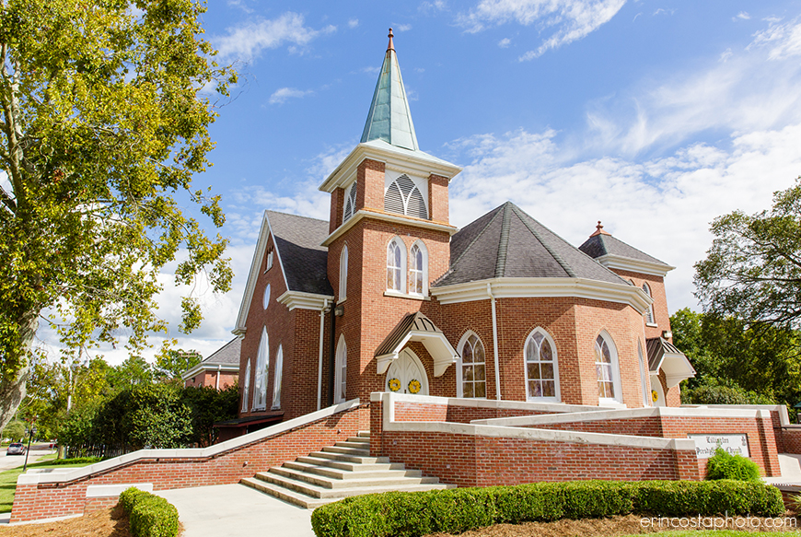
† You are invited to stand when you see this symbol.

PRELUDE Savior Like a Shepherd

WELCOME AND OUR LIFE TOGETHER

PRAYER OF APPROACH

† CALL TO WORSHIP
The Lord is my Shepherd
I shall not want
I seek the grace of God
and my cup runneth over
I seek the will of God
and my cup runneth over
I seek the strength of God
and my cup runneth over
How generous is God's love
and my cup runneth over
The Lord is my Shepherd
I shall not want
† HYMN #39 Great is Thy Faithfulness _{FAITHFULNESS}

† CALL TO CONFESSION

† PRAYER OF CONFESSION The Abingdon Worship Annual
(silent prayer)
Messiah, your presence fills our lives—
all that we are and all that we have comes from you;
all that you do declares your love for us.
Yet when trouble comes, when adversity plagues us,
we wonder where you are; we even wonder who you are.
How quickly we forget that you are always with us.
Dispel our gloom and despair.
Change our garments of darkness into robes of dazzling light.
Spread your table before us and feed us from your hand.
Lead us in the paths of righteousness,
for it is in your name that we pray. Amen.

† ASSURANCE OF PARDON

† PASSING OF THE PEACE
May the peace of Christ be with you.
And also with you.

† RESPONSE OF PRAISE refrain from Christ Has Arisen, Alleluia

Let us sing praise to him with endless joy.
Death’s fearful sting he has come to destroy.
Our sin forgiving, alleluia!
Jesus is living, alleluia!

FAITH SHARING WITH CHILDREN

PRAYER OF ILLUMINATION

OLD TESTAMENT LESSON Psalm 23 _{page 501 OT}

ANTHEM The Lord is My Shepherd Chancel Choir

GOSPEL LESSON Acts 16:16-34 _{page 136 NT}

SERMON Rev. Dr. Jenny Lee

† HYMN #803 My Shepherd Will Supply My Need _{RESIGNATION}
ORDINATION AND INSTALLATION Larry Schiemann

† AFFIRMATION OF FAITH Apostles Creed

I believe in God, the Father Almighty, maker of heaven and earth,
and in Jesus Christ, His only Son, our Lord:
Who was conceived by the Holy Ghost, born of the virgin Mary,
suffered under Pontius Pilate, was crucified, dead, and buried;
He descended into hell. The third day He arose again from the dead;
He ascended into heaven,
and sitteth on the right hand of God the Father Almighty;
from thence he shall come to judge the quick and the dead.
I believe in the Holy Ghost;
the holy catholic church;
the communion of saints;
the forgiveness of sins;
the resurrection of the body;
and the life everlasting. Amen.

PRAYERS OF THE PEOPLE AND THE LORD’S PRAYER

...Our Father who art in heaven, hallowed be thy name. Thy kingdom come, thy will be done, on earth as it is in heaven. Give us this day our daily bread; and forgive us our debts, as we forgive our debtors; and lead us not into temptation, but deliver us from evil. For thine is the kingdom and the power and the glory, forever. Amen.

INVITATION TO OFFERING

OFFERING MUSIC Be Still, My Soul

† DOXOLOGY Doxology

Praise God, from whom all blessings flow;
Praise Christ, all people here below;
Praise Holy Spirit evermore;
Praise Triune God, whom we adore. Amen.

PRAYER OF DEDICATION

† HYMN #821 My Life Flows On _{HOW CAN I KEEP…}

CHARGE AND BLESSING

POSTLUDE Send the Light
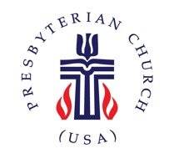
Church Information

Mailing Address: | PO Box 245 Lillington, NC 27546
Phone: | 910-893-3545
Website: | www.lillingtonpres.org
Office Hours: | t-F 8:30AM-12:30PM

Church Staff
Pastor:  Rev. Dr. Jenny Lee | Pastor@lillingtonpres.org  910-893-3545
Music Director:  Wanda Brown | music@lillingtonpres.org  910-890-0900
Children’s Ministry Director:  Amanda Inguanza | christianed@lillingtonpres.org  657-250-1495
Bookkeeper:  Miranda Owen | Accounting@lillingtonpres.org  910-893-3545
Administrative Asst.:  Paula Stephenson | office@lillingtonpres.org  910-893-3545
Sextons:
Rose and Elmon Pipkin, Jr

Session
Moderator: Rev. Dr. Jenny Lee
Clerk: Jim Cruickshank

Class of 2024 | Class of 2025 |  | Class of 2027
Al Bain |  | Betsy McCormick | Anna Langdon
Christine Cox |  | Josh Smith | Tom Scheunemann
Chris Newcomb |  | John Wilbourne | Larry Schiemann
Jeff Paschal

Search Lillington Presbyterian Church on your favorite podcast provider
for more sermons and series.

