
LILLINGTON
PRESBYTERIAN
CHURCH
May 17, 2026
Seventh Sunday in Easter
† You are invited to stand when you see this symbol.
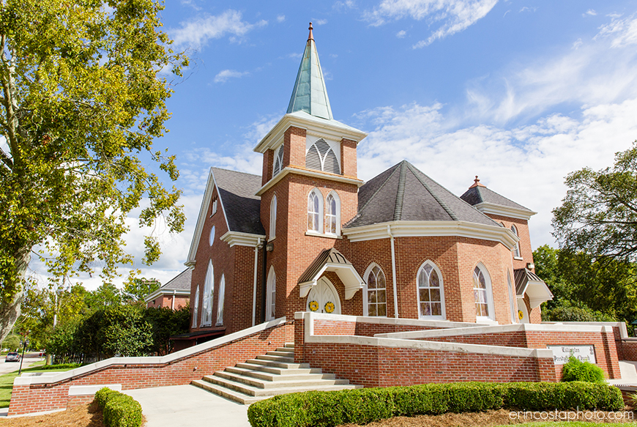

PRELUDE In Moments Like These

PROCESSION OF GRADUATES

WELCOME AND OUR LIFE TOGETHER

PRAYER OF APPROACH

† CALL TO WORSHIP

† HYMN #263 All Hail the Power of Jesus’ Name! _{CORONATION}

† CALL TO CONFESSION

† PRAYER OF CONFESSION
(silent prayer)
We would want to be fountains of hope for others, God of glory,
but people find only hardened hearts.
We would like to be transformed people,
but our stubborn pride prevents us from bending a knee to you.
We long to stand with those who are in need,
but our selfishness keeps our backs rigid in judgment.
Forgive us, God who came down to us.
Humble us, that we might be true servants to the broken and lost.
Split open our frozen hearts,
that compassion might flow freely to those who are hurting.
Fill our minds with the presence of your Spirit,
that we might learn how to follow Jesus Christ, our Lord and Savior,
into that kingdom of grace and hope.

† ASSURANCE OF PARDON

† PASSING OF THE PEACE
May the peace of Christ be with you.
And also with you.

† RESPONSE OF PRAISE refrain from Christ Has Arisen, Alleluia
Let us sing praise to him with endless joy.
Death’s fearful sting he has come to destroy.
Our sin forgiving, alleluia!
Jesus is living, alleluia!

FAITH SHARING WITH CHILDREN

PRAYER OF ILLUMINATION

GOSPEL LESSON Luke 6:43-45 _{page 65 NT}

ANTHEM I’ll Fly Away Chancel Choir

EPISTLE LESSON Philippians 2:1-13 _{page 197 NT}

SERMON Rev. Dr. Jenny Lee

† HYMN #727 Will You Let Me Be Your Servant _{THE SERVANT…}
† AFFIRMATION OF FAITH Apostles Creed

I believe in God, the Father Almighty,
maker of heaven and earth, and in Jesus Christ, His only Son, our Lord:
Who was conceived by the Holy Ghost, born of the virgin Mary,
suffered under Pontius Pilate, was crucified, dead, and buried;
He descended into hell.
The third day He arose again from the dead;
He ascended into heaven,
and sitteth on the right hand of God the Father Almighty;
from thence he shall come to judge the quick and the dead.
I believe in the Holy Ghost;
the holy catholic church;
the communion of saints;
the forgiveness of sins;
the resurrection of the body;
and the life everlasting. Amen.

PRAYERS OF THE PEOPLE AND THE LORD’S PRAYER

...Our Father who art in heaven, hallowed be thy name. Thy kingdom come, thy will be done, on earth as it is in heaven. Give us this day our daily bread; and forgive us our debts, as we forgive our debtors; and lead us not into temptation, but deliver us from evil. For thine is the kingdom and the power and the glory, forever. Amen.

INVITATION TO OFFERING

OFFERING MUSIC Spirit of the Living God

† DOXOLOGY Doxology

Praise God, from whom all blessings flow;
Praise Christ, all people here below;
Praise Holy Spirit evermore;
Praise Triune God, whom we adore. Amen.

PRAYER OF DEDICATION

† HYMN #372 O For a World _{AZMON}

CHARGE AND BLESSING

POSTLUDE God of our Fathers
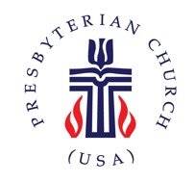
Church Information

Mailing Address: | PO Box 245 Lillington, NC 27546
Phone: | 910-893-3545
Website: | www.lillingtonpres.org
Office Hours: | t-F 8:30AM-12:30PM

Church Staff
Pastor:  Rev. Dr. Jenny Lee | Pastor@lillingtonpres.org  910-893-3545
Music Director:  Jarrod Davis | music@lillingtonpres.org  910-893-3545
Accompanist:  Wanda Brown | wandagcbrown@gmail.com  910-890-0900
Children’s Ministry Director:  Amanda Inguanza | christianed@lillingtonpres.org  657-250-1495
Bookkeeper:  Miranda Owen | Accounting@lillingtonpres.org  910-893-3545
Administrative Asst.:  Paula Stephenson | office@lillingtonpres.org  910-893-3545
Sextons:
Rose and Elmon Pipkin, Jr

Session
Moderator: Rev. Dr. Jenny Lee
Clerk: Jim Cruickshank

Class of 2024 | Class of 2025 |  | Class of 2027
Al Bain |  | Betsy McCormick | Anna Langdon
Christine Cox |  | Josh Smith | Tom Scheunemann
Chris Newcomb |  | John Wilbourne | Larry Schiemann
Jeff Paschal

Search Lillington Presbyterian Church
on your favorite podcast provider for more sermons and series.

Liturgy by Michael Perry of the Jubilate Group and Thom Shuman. All rights reserved. Used by permission.

